Wireless Applications Involving:
Electronic Paper (E-Paper)
© 2008 The Late Circle Group

Where do you see the world in 10 years?
Massive communities coming together – its inevitable
Technology evolving – its inevitable
The Wireless Revolution – its inevitable.

Objective
The overall objective of the design is to implement wireless communication networks for applications on display technologies, such as: wireless transfer of data between displays, information scaling, and display coordination. An additional design feature is enabling the wireless transfer of data from a computer to the display. The design is envisioned to be as easy to use as possible utilizing automatic configuration, position based commands and reliable data transfer. This design project will primarily focus on quasi-static display technology, though in principle could be applied to a wide array of technologies and applications. The ideal display technology for use with this design is a new and emerging technology known as electronic paper.

Electronic Paper and Electronic Readers
Electronic paper (e-paper) is a display technology designed to mimic the appearance of ordinary ink on paper. Unlike a conventional flat panel display, which uses a backlight to illuminate its pixels, electronic paper reflects light like ordinary paper and is capable of holding text and images indefinitely without drawing electricity, while allowing the image to be changed later. The mechanics of electronic paper work on the principle of applying charge to each pixel of the display, which contains positively charged white and negatively charged black particles. Applying a charge to a pixel causes either the white or black particles to come forward, causing the electronic paper to appear light or dark in that region. Because the pixel consists of the physically colored particles contained within it, the electronic paper appears to contain “ink” as opposed to emitting light. Additionally, current e-paper technology supports approximately 150 to 200 dots, or pixels, per inch, which is comparable to current printed material.
Electronic readers (e-readers) are a current application of electronic paper displays that allow a user to view documents and images on a portable, long-battery-life device. The simplest e-readers consist of an e-paper display, a memory module to store documents, and a controller to interpret user input and run the display. Current products on the market include additional features such as Wifi, Bluetooth, and touch screen technology. No existing e-reader product incorporates coordination between devices that would allow for unique and innovative applications of swarming and networking. Additionally, they can only transfer personal documents from a computer, necessitating the inconvenient use of cables in a world that is continually transitioning towards wireless.

Network and Applications Overview
The communications network to be designed and constructed will be comprised of individual devices known as sensor arrays, which each consist of four individual sensors placed on the center of each edge of the display device. These sensors will act as transceivers that will transmit and receive information and additionally serve to designate the display’s appropriate position while cooperating with other displays in a swarm. The exact sensor technology will be discussed in more detail in the Technical Details section.
One specific application of the sensor array is as an enabling technology for electronic reader swarming and communication. Inclusion of the sensor array would allow for wireless transfer from a desktop/notebook computer to the e-reader via a specially designed wireless USB adapter for computers. The sensor array could additionally be used to perform wireless document transfer between multiple e-readers and potentially other forms of information sharing. One possible implementation of document transfers would be initiated by simply placing one e-reader above another such that all four sensors of both devices align as shown in Fig. 1. Other innovative forms of document sharing among display devices could be implemented, such as multiple page display and image scaling. While displaying a document comprised primarily of text, multiple pages of the same document may be viewed by placing multiple e-reader devices next to each other, side by side as in Fig. 3; this action will initiate small, one-page data transfers consisting of pages from the original document from device to device. While displaying an image on one device, bringing other devices nearby such that a rectangular formation is laid out causes the original image to be scaled over all devices, as seen in Fig. 2.

Technical Details
Two potential technologies were researched for implementation of the sensor arrays: infrared (IR) and radio frequency (RF). Both IR and RF technologies examined for possible use have been chosen for a trade-off of high speed and low power consumption. This is due to the fact that the sensor array concept is to be applied to existing devices, such as low power e-readers, which have a limited battery life and strict power budgets. While the swarming and information-sharing component may not be utilized as extensively as actual document display on these devices, minimal battery-life loss is essential for this technology to be adopted by existing products.
Low power consumption, along with high-speed transfer rates and inherent security are key features of infrared technology. As an example, the TFDU8108 transmitting and receiving IrDA, from Vishay/Semiconductors, is a very fast infrared transceiver module that supports 16 Mbit/s, 4 Mbit/s, and 1152 kbit/s. It has an operating supply voltage from 2.7-5.5 V, a 2 mA idle supply current, an average output current of 130 mA and a power dissipation of approximately 350 mW. The inherent security of infrared systems lies in their requirement of line of sight for communications, which significantly reduces the likelihood of unwanted intruders gaining access to information contained on the device. The communication range between devices is dependent on the amount of power supplied to the infrared chip, which can be operated to have a range of 0.1 to 2.5 meters. This limited range is ideal for a communication network consisting of devices designed to be operated in close proximity of each other. An additional advantage of both the limited range and line of sight properties of infrared is the reduction of interference between nearby devices. A major disadvantage of the infrared technology proposed, however, is that the TFDU8108 transceiver is the only known infrared component to operate at these high speeds.
The use of an RF transceiver system for sensing and sharing data was found to be comparable to infrared in many aspects. Additionally, unlike the infrared solution there are many RF chips capable of the necessary speeds and low power consumption required for this design. For instance, the Atmel ATR2406 2.4 GHz transceiver supports a maximum bit rate of 1.152 Mbps at a supply voltage of 2.9 – 3.6 V. Typical current figures are 57 mA for receive and 42 mA for transmit. Calculating for worst-case instantaneous power yields 150 – 205mW. Along with lower power consumption, the RF chips allow for communication when no line of sight is present, unlike their infrared counterparts.
Table 1 shows a comparative analysis of different communication technologies in terms of their transfer rates and estimated time to complete data transfers of given sizes.

Table 1: Data Rates and Time-to-Completion for Different Technologies
Approximate  Page Length | Data size  (kbytes) | Data size  (kbits) | Data rates  (kbits/s) | Time  (s) | Comment
1000 | 2000 | 16000 | 1100 | 14.54545 | TFDU8108 (MIR)
1 | 6 | 48 | 1100 | 0.043636 | TFDU8108 (MIR)
1000 | 2000 | 16000 | 4000 | 4 | TFDU8108 (FIR)
1 | 6 | 48 | 4000 | 0.012 | TFDU8108 (FIR)
1000 | 2000 | 16000 | 9600 | 1.666667 | TFDU8108 (VFIR)
1 | 6 | 48 | 9600 | 0.005 | TFDU8108 (VFIR)
1000 | 2000 | 16000 | 16000 | 1 | TFDU8108 (VFIR)
1 | 6 | 48 | 16000 | 0.003 | TFDU8108 (VFIR)
1000 | 2000 | 16000 | 1000 | 16 | CC1101 RF Chip
1 | 6 | 48 | 1000 | 0.048 | CC1101 RF Chip
1000 | 2000 | 16000 | 1152 | 13.88889 | ATMEL ATR2406 RF Chip
1 | 6 | 48 | 1152 | 0.041667 | ATMEL ATR2406 RF Chip

After comparing both technologies’ strengths and weaknesses, it was found that radio frequency technology provided a more appropriate fit for the envisioned applications of the sensor arrays. RF was chosen due to its increased versatility, lower power consumption, and increased availability over infrared products.

Example Implementation and Feasibility
One of the most popular e-reader devices on the market today, the Amazon Kindle, uses a 1530 mAh lithium ion battery and lasts approximately seven days with its wireless internet connection disabled. With wireless enabled, the Kindle’s battery lasts approximately two days. Ideally, the addition of swarming sensors and their application to a product such as the Kindle should reduce its existing battery life by less than a day. Utilizing the Kindle’s expected battery life and known battery capacity, the average continuous current drawn by the Kindle during a 7-day period was calculated as approximately 6.375 mA assuming 70% battery power factor. Two use cases are now examined: light use of 5 pages, or 30 kB, transferred per day; and heavy use of 100 MB of documents and images transferred per day. Both cases will be calculated using the Atmel ATR2406 RF chip as an example.
For the case of light use the 30 kB can be transferred in, at best, 208 msec per day. The ATR2406 chip draws a current of 42 mA for transmission, which calculates to 2.43 uAh per day of transmission. Assuming additional consumption of the device equaling that of the transmitter, the total consumption per day becomes 153.49 mAh. At this rate, the Kindle would last approximately 6.98 days. For the case of heavy use the 100 MB can be transferred in, at best, 700 seconds. At 42 mA current draw for transmission, this becomes 8.16 mAh per day of transmission. Again, assuming additional consumption of the device equaling that of the transmitter, the total consumption per day becomes 169.3 mAh. At this rate, the Kindle would last approximately 6.32 days. It is important to note that these figures make many assumptions on the nature of the chip’s operation, such as using the average value of current consumption over a day instead of actual consumption, and the amount of power that will be lost for re-transmitting and used by the Kindle device itself. Nonetheless, it can be seen that the technology chosen for this application will allow for a minimum amount of battery-loss in current technologies, increasing the potential for adoption.

Design and Verification
The wireless communication network will be designed and verified in four phases. The first phase will be the construction of a wireless communication network consisting of two transceivers that are able to transmit and receive data to and from each other, as shown in Fig. 4. Next, testing will be done to allow the transceiver to operate at the appropriate speed. Measurements will then be made to observe the current and voltage drawn given the mode of operation the transceiver is set at. After verifying the proper procedure to use these transceivers, work may begin on the second phase. The second phase will involve constructing a sensor array with four sensors positioned at the center of each side of the device, as shown in Fig. 5. Each of the sensors will be connected to a central controller for independent operation. A microcontroller and USB module will be implemented into the array to transmit data to and from a computer, which will be used as the display for testing purposes.
The third phase will consist of two to six sensor arrays configured to test network communication, as shown in Fig. 6. First, testing will involve communication between two sensor arrays in the absence of interference. This design will be verified by connecting each array to a computer and copying a document from one to the other. Second, the two sensor arrays will be operated in the presence of a third array providing interference. Third, a multi-array network will be set up and tested to ensure that the communication operates properly with multiple devices. Each array’s sensors will be configured to only communicate with the adjacent sensor array. This will be achieved by using a combination of signal strength and physical identification of the device.
The final phase will involve implementing the algorithms that will enable applications of image scaling, easy data copying, and multiple page document display, as seen in Fig. 7. Image scaling will be activated if three conditions are met: first, an image must be the displayed media; second, sharing mode must be enabled; and third, the orientation of the swarming devices must be rectangular in shape as shown in Fig. 3. Easy data copying will be activated if two conditions are met: first, sharing mode must be enabled; second, all four sensors of two devices must line up directly as shown in Fig. 2. Multiple document display will be activated if two conditions are met: first, a text document must be the displayed media; second, sharing mode must be enabled. Fig. 1 shows an application of multiple document display.

Cost Analysis
In constructing a working prototype, the unit cost of the Atmel ATR2406 RF transceiver integrated circuit chip is $3.83 resulting in a cost of $15.32 for the sensor array on each display. Linx Technologies’ SDM-USB-QS-S USB module has a cost of $13.91 and the Atmel AT90USB162-16AUR microcontroller integrated circuit chip has a cost of $3.76. The USB module and microcontroller will enable the sensor arrays to receive and transmit data to the computer display as a verification that the prototype networks work properly. The total cost for each prototype will be $32.99 not including the cost of the display, which will be implemented in the prototype using either tablet PC’s or flat-screen televisions. It is required that the minimum number of prototypes needed, to confirm that algorithms for swarming and image scaling function properly, will be six, bringing the total minimum cost of parts to be ordered to $197.74. In developing a functional system to work with already existing e-paper technology (which include the display and controlling technology), parts may be purchased in bulk quantities. This will reduce the price of each RF transceiver to $2.19 per unit for every purchase greater than or equal to 1000 units. Also, there will be no need for a USB module and microcontroller due to the fact that these sensors will be connected directly to the e-paper display product’s internal CPU and memory. Therefore, the implementation of this wireless communication network on e-paper technology will have an approximate cost of $8.76. Compared with this low cost of implementing these sensor arrays into existing technology, it can be observed that there is a great gain to be made when compared with the societal impacts as mentioned earlier.

Societal Impact and Conclusions
Having this technology will first and foremost eliminate the use of wires, resulting in a much easier way to transfer data between computers and different types of display technologies. Additionally, with the aforementioned sharing capability, people will have the ability to share and view documents that may be of importance with ease. This would be an ideal application for the workplace, educational institutions, and even at home. Finally, with its ease of use and sharing capabilities, consumers will be more inclined to purchase these display technologies such as e-paper displays. Using e-paper displays eliminates the use of paper and therefore will reduce the amount of trees cut down, decreasing the amount of carbon dioxide in the atmosphere destroying the ozone layer and the habitats of many wildlife and endangered species. In all, the use of wireless communication networks for applications involving display technologies such as electronic paper displays will help advance the green movement in improving our environment for a better tomorrow.

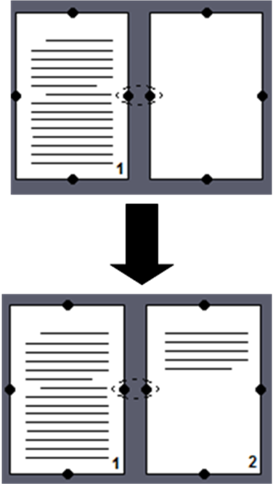
Fig. 1 Fig. 2

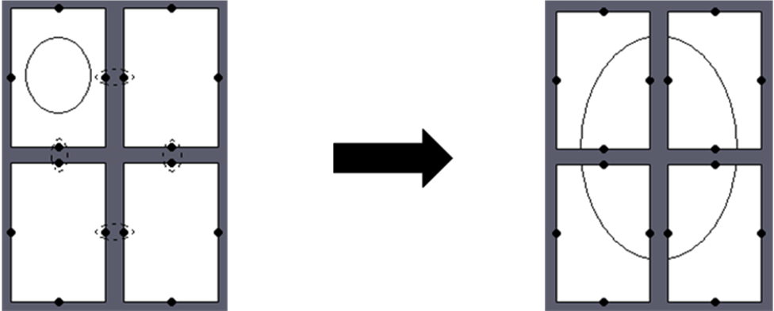
Fig. 3
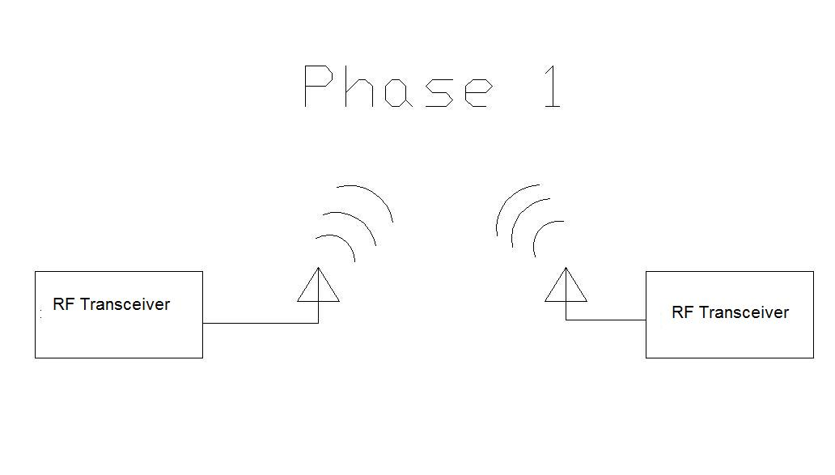
Fig. 4
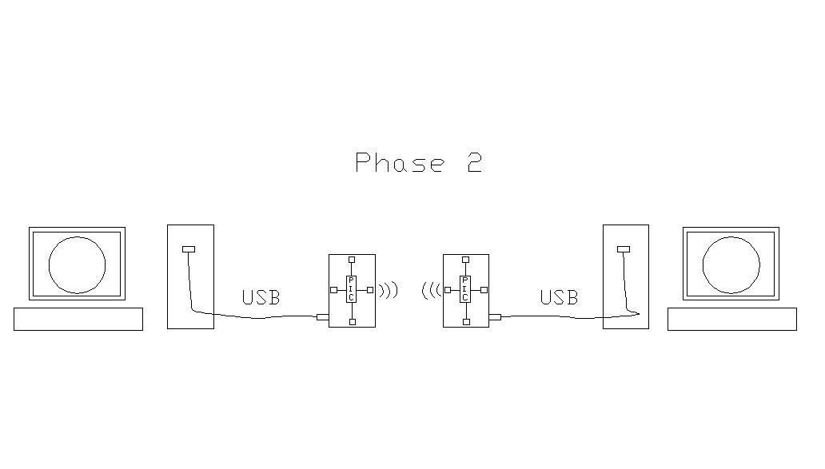
Fig. 5

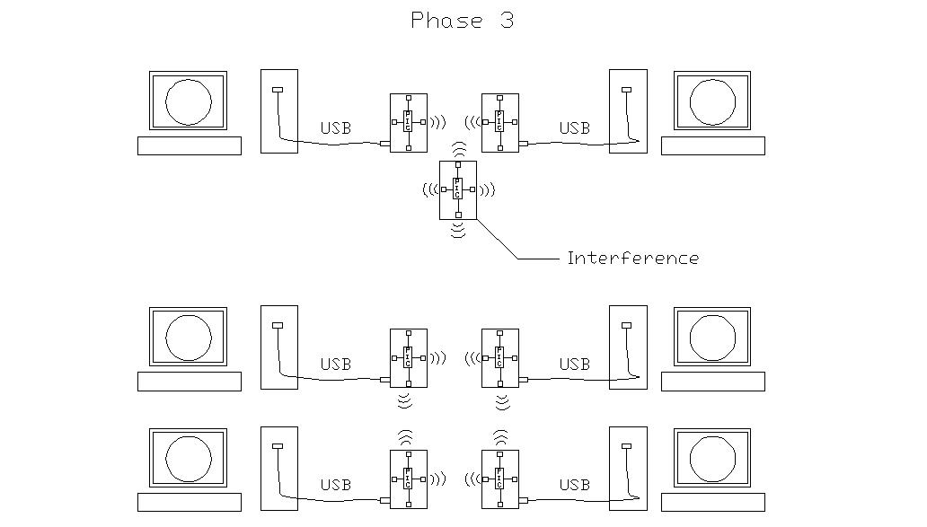
Fig. 6
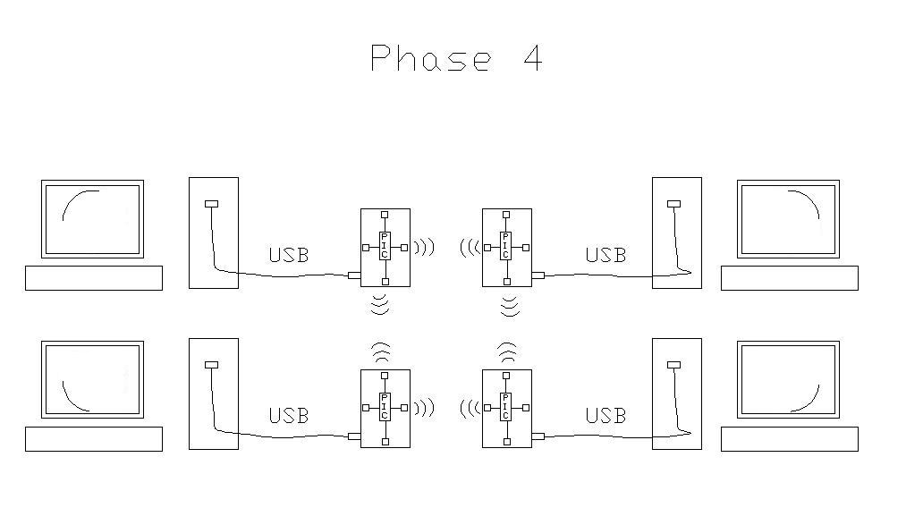
Fig. 7

