Wireless Communication Systems
14:332:421
Professor Chris Rose
Capstone Design Proposal
@Your Service
Created By:
Kevin Allen
Jonathan Chichioco
Amir Fantroyal
Kevin McNaughton
Motivation and Objective
A typical shopping scenario for any person would be in which one were to be in a long line at a department store or warehouse supplier, waiting to ask a question, with multiple distractions and interferences prohibiting anyone from being served or helped in a timely and efficient manner. Such obstacles could include, people cutting in line, passing others because they have a “short” question that could turn into a long one, or an emergency that requires a person to leave their spot in line, such as going to the bathroom.
@Your Service is a revolutionary system that will allow customers to wait in line while shopping elsewhere. The patron simply enters a virtual line and is notified when it’s close to their turn. With this system one won’t have to worry about cutting in line or losing their spot because it will all be kept in a computer database.
In order to use this system, customers will need to have a membership card for the particular store they are shopping at (e.g. ShopRite Price Plus or Costco Membership card). The card will be swiped at a customer service kiosk through normal store hardware and software. Through a series of easy to use touch screen options, the computer will give an estimate of how long they’ll have to wait in line and a prediction of which customer representative is going to be taking care of them. Upon confirmation, the customer will be added to the queue, and will be given a notification device. For the duration of the wait period, customers will be free to roam the store, and find any other items that they would like to buy. When it is near time for them to be taken care of, the notification device will vibrate, notifying the customers that it is time to return to their departments of interest.
On top of the basic features, customers can check their status in the queue by going to any customer service kiosk and swiping/scanning their card and if desired, remove themselves from the queue. Another way to take oneself out of line would be to exit the store. Notification devices can be returned to a designated employee upon exiting the store.
If a customer does not show up when the wait is over, and isn’t on his or her way to the department of interest, the customer will be moved down one slot in the queue and will be notified again shortly before the employee has finish assisting the next customer. A customer will remain on the queue until they cancel their question at a customer service kiosk, or leave the store. A customer’s location will be determined via RFID (Radio Frequency Identification) tags inside the notification device. This allows the staff to see if the customer is close and on his or her way or if they are far away and should be moved down in the queue.
Overall, @Your Service eliminates the hassle of physically standing in line while maintaining integrity and establishing fairness by preventing line cutters from complicating each customer’s experience.
Implementation
Before implementing this system, it is important to know how basic RFID technology works. RFID requires a reader, which has an antenna and a receiver to interpret the data received by the antenna, and a tag (usually multiple) containing the needed information. Each tag may be scanned through antennas located in the area. These antennas transmit a modulated signal to the RFID chip. As the chip demodulates the signal, it allows the RFID tag to transmit the information on the chip to the scanning antenna by sending a modulated signal back. The scanner will pick up this signal and the data will be interpreted and interrogated for specific use.
For this system, a basic template will be used for different types of store layouts. A store with its departments arranged in a symmetrical fashion will require an antenna layout different than a store with its departments scattered around. In determining whether active or passive RFID tags were going to be used, a few factors had to be examined. The main disadvantage between active and passive RFID tags is that active tags are battery powered, and therefore are slightly larger in size. The advantage to using an active RF tag compared to a passive tag is that active tags can be detected at much larger distances in the range of a 100 yard radius. Since passive tags have a maximum detection distance of about 30 feet, it would be more efficient to use active tags, which will require less antennas throughout the store. It’s going to be important to make sure that there are absolutely no dead zones in the store. However, there will undoubtedly be areas in the store that will have intersecting regions of coverage from two adjacent antennas. These areas will make the employees’ job much easier in determining where the customer is located, because when they see that a certain employee’s tag is detected by two adjacent antennas, it then alerts the employee that the customer is located in the intersecting region of the two antennas.
The antennas will then cover each department of the store. If a particular department’s antenna picks up a strong presence of the desired RFID tag, the system will then indicate that the customer is in this particular region of the store. The reasoning behind this is because employees will only need the vicinity of where a certain customer is located, and not the exact location, like a global positioning system. This simplifies the issue of where a customer may be located.
In terms of connections, each antenna will need to be able to send the information regarding whether or not it is detecting a specific RF tag, to one of the employee kiosks. This is done through interfacing software. From here, the employee kiosks will be connected to the main network and each kiosk will use a queuing system which will dictate where every customer belongs on the list. The RF network will be responsible for two things: transmitting a signal to cause the customers’ notification device (with the RF tag) to vibrate, and to locate the actual devices via the antenna network.
The customer’s membership card will have a magnetic strip that they will swipe initially at one of the customer kiosks to “log in” and obtain a spot on the waiting list. This portion of the system will not be explored as it does not have technical relevance to the actual project. The card is simply using technology that the store already has available to them.
As shown on the floor layout diagram in Fig. 1, there will be six departments in the model store. Two adjacent departments will be 80 ft. x 40 ft, the next two will be 60 ft. x 40 ft, and the remaining two will be 40 ft. x 40 ft. Each of the six departments will have one RFID reader located at a central location, with the customer kiosk. The reader will have an Omni-directional antenna that will be able to identify the notification devices for ranges up to 100 meters. One important factor to note is that each of these antennas will have the ability to be adjusted so that the range can be set from as little as 5 meters, to as much as 100 meters. Since the model store being analyzed has three duplicate departments (in terms of area), it is necessary to have three different antenna settings. The idea behind determining how much intensity should be used for each department’s antenna, is based on creating a circle of intensity that will touch the four corners of the department. This will minimize the amount of overlapping to adjacent departments, thus making it easier for the employee to track where a specific customer is located, as well as eliminating the possibility of dead zones. As can be seen in Fig. 1 the Roadshop and Toys department have a small overlapping region because of the 40 ft. length of each department. Since both the Merchandise and Appliances departments have a 60 ft. length, the antennas will emit more power to cover a larger region. Because these two departments have different lengths than widths, the overlapping region will need to be slightly larger. Finally the two largest departments in the store, which are each comprised of 80 ft. x 40 ft. dimensions, will have an even bigger overlapping region. The widths of all of the departments are the same, so, the four instances where two different sized sections overlap will cover the same amount of area. This is only a template for the most symmetrical of stores. Companies that implement this system will need to sit down with a consultant to figure out exactly how the system will most efficiently be implemented to benefit their store.

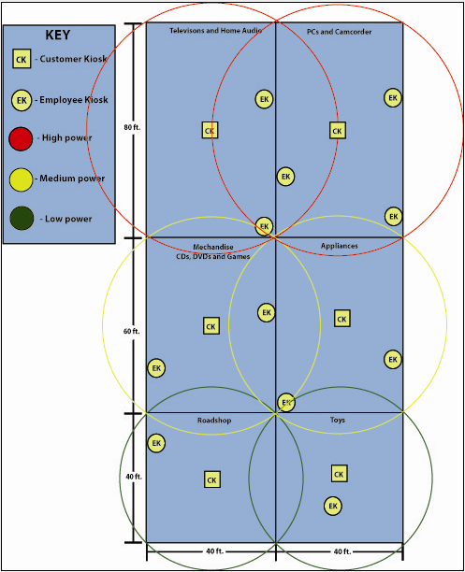

Fig. 1: Floor layout of model store

Queuing System
@Your Service will be utilizing a system in order to properly queue the customers according to their entry into the store and desire to find help. It is important, and one of the main reasons for implementing the @Your Service system, that the customer receives a fair and proper opportunity to receive help on a "first come, first served" basis. This ideal will provide order and organization to the store’s functionality and help address any concerns on improving customer service. However, due to possibility of customers holding quick response questions and waiting longer periods of time, there will be two sets of employees. One set of employees will oversee general questions that may range in the amount of time required to answer them. The other set will answer questions specific to minor details that do not require long explanations and may admit about 5 minutes at most per customer. An example of how this is used is at supermarkets and their express checkout lanes. Although, there are times that customers will go over the limit of how many products are allowed to be checked out at these lanes, the system itself is monitored for the most part to ensure that customers’ convenience is not being sacrificed for this privilege. Likewise, with customers who may have questions that exceed the general amount of time for the “express” employees will still be attended to while those customers still in the queue may be moved as free employees become available. The purpose is to fully maximize both employees’ offered skills and time available to customers as well as minimize customers’ hassle and wait times. By observing backed up lines for customer support, customers may be moved by the store’s administrator, the one overseeing the service, in order to keep customers from waiting for too long.
A principle that is similar to this system is a First In First Out (FIFO) discipline. The customer that has been waiting the longest will be served first per employee. However, customers will be distributed to the next available employee in the department of the store they need assistance in. Generally, questions may be about 15 minutes per customer. If there are two employees helping one customer each, and a third customer desired help, the third customer’s wait time is based on how long each employee has been working with their respective customer. For example, if employee 1 serves customer A at 4:30 PM and employee 2 serves customer B at 4:35 PM, customer C will be queued to employee 1 since the system will assume that the estimate of 15 minutes will be up earlier for employee 1 rather than for employee 2. In the event that employee 2 finishes before employee 1, employee 2 or the service administrator may move customer C to employee 2 to keep them from waiting.
Pseudocode for the queuing algorithm has been added to provided a general overview of how customers will be distributed among employees:

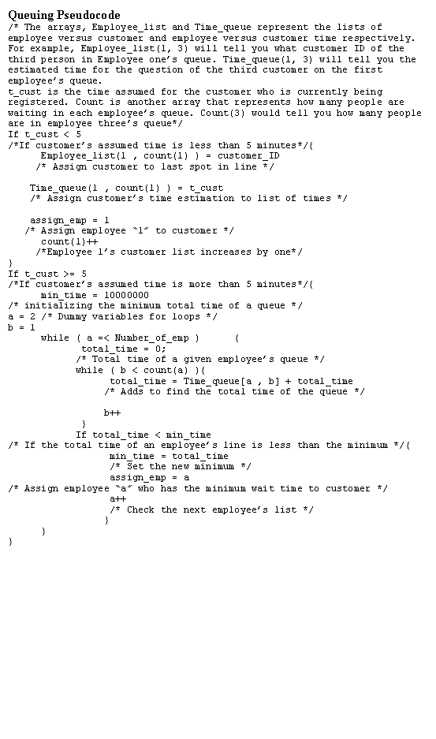

A function of the service is to minimize waiting time for all customers. So if after a customer has been paged, but s/he doesn’t wish to be tended to at the time or is held up at a different part of the store, s/he will be moved down one spot in the queue to make room for the next available customer. Although this may seem like the customer is being penalized, it allows customers to have the freedom to browse the store without feeling “chained” to a particular department waiting to be helped. The employee will have the ability to page the customer a few minutes in advance in order to give some time for the customer to make it to the part of the store they need to be in. The employees’ ability to see which part of the store the customer is in will allow them to gauge how long the customer may take to reach them.
Cost, Detail and Design
RFID reader:
An RFID reader typically contains a module (transmitter and receiver), a control unit and a coupling element (antenna). The reader has three main functions: energizing, demodulating and decoding. In addition, readers can be fitted with an additional interface that converts the radio waves returned from the RFID tag into a form that can then be passed on to another system, like a computer or any programmable logic controller. Anti-Collision algorithms permit the simultaneous reading of large numbers of tagged objects, while ensuring that each tag is read only once. In this system the RFID reader will typically be located in multiple locations throughout the store to pickup the RFID tag. The price of the reader is $1,350 for an XR440 Fixed RFID Reader which operates in the Ultra High Frequency (UHF) Band of about 2.4 – 2.5 GHz. The size of the store would determine how many RFID Readers would be needed; however an average number would be about six reader devices which adds up to $8,100.
Customer Notification device:
RFID tag -
The tags chosen to be used in this system are Active RFID tags as opposed to Passive RFID tags. The tags are used to pick up the RFID signal to notify the customer to return to the department in question. Active tags differ in that they incorporate their own power source, where as the tag is also a transmitter rather than a reflector of radio frequency signals which enables a broader range of functionality like programming and read/write capabilities. An RFID tag is an object that can be applied to or incorporated into a product for the purpose of identification and tracking using radio waves. Some tags can be read from several meters away and beyond the line of sight of the reader. RFID tags contain at least two parts; an integrated circuit for storing and processing information, modulating and demodulating a radio-frequency (RF) and the second being an antenna for receiving and transmitting the signal. Active RFID tags have their own internal power source, which is used to power the integrated circuits and to broadcast the response signal to the RFID reader. Communications from active tags to readers is typically much more reliable, therefore having less error than those from passive tags due to the ability for active tags to transmit information to the reader. Active tags, due to their onboard power supply, also may transmit at higher power levels than passive tags, allowing the signal to be more distinguishable in bad weather conditions, high density areas, reflective targets from metal, or at longer distances, which may be more ideal for large department stores. In turn, active tags can be larger (due to battery size) therefore making it more expensive to manufacture. However, the potential shelf life of an active tag can be many years, preventing the need for stores to replace old tags. Active RFID tags costs around $22 and an average of 100 tags would cost about $2200.
Vibrating Motor -
The vibrating motor inside the customers’ notification device is used to notify a customer when an employee is waiting for them. How this motor will operate isn’t a relevant issue to this project, however it is important to know the cost for mass production of customer tags. A tiny .16” DIA vibrator motor operates on 1 – 5VDC for the cost of only $1.95 per motor for 100 motors.
LED -
Light Emitting Diodes (LEDs) can be used for visual purposes in the customers’ notification device. An LED is usually a small area (less than 1 mm²) light source, often with optics added directly on top of the chip to shape its radiation pattern and assist in reflection. The small 1206 LEDs that will each be placed inside each device will cost about $23.99 for 100 pieces.
The total amount for 1 notification device would be about $30 to include plastic casing for the circuitry and internals used. A total of about 100 customer notification tags would cost around $3000.
@Your Service Kiosk
Kiosk Design -
The design of the kiosk will use an LCD touch screen monitor that will be self standing located in every major department in the store. To receive the actual price, the consumer will need to consult with the manufacture for specific additions to the kiosk.
Kiosk Software -
The @Your Service Kiosk software will be created and used for the aid of customer’s questions so that they will have more order in the department stores and the user will be following onscreen instructions.
The average cost for a typical kiosk would be similar to that of a normal personal computer, around $500. With an average of six departments, and six kiosks, this will place a cost for service kiosks at $3000.
Grand Total: ~ $14,100.00
Although this cost may seem very high for one particular department store, it has been shown that customer service has always been a high priority for any store. Store managers know that when customers are happy and satisfied, customers are likely to buy more. Not only will customers increase their purchases, but they will continue to come back to the store because of their track record. Stores will then go through the efforts in increasing support for customers. With the organization of the service, it will also enable order and satisfaction for employees as well. Disgruntled employees hinder open service to all customers and show inefficiency in store operation. With employees finding less chaos in their jobs, they will enjoy their work and find their jobs easier.
Alternative Services
When implementing @Your Service, it is understood that there are other possible solutions to improving customer service. There are advantages to using these approaches, however, at the same time these solutions also hold their disadvantages.
One possible solution is instead of using RFID technology for notification tags, utilizing customer cell phones by sending a text message or a phone call to notify them when a customer service representative is available.
One advantage of this method is its minimal cost compared to RFID technology. This method uses equipment that the customers already own. Therefore, there is no need to purchase RFID readers, or RFID tags to be given out to customers. This also relieves the responsibility of keeping track of all the devices that were possibly used by the customers and keeping them within the store.
The disadvantages of using the cell phone approach include the following:
Text messaging: If text messages were used to notify the customers, this approach may lead to some delay in notification. Text messages are frequently delayed at times depending on service and usage of cellular networks. This traffic activity cannot always be maintained and monitored for the purposes of improving the quality of customer service. Using text messages may not always be reliable in a fast paced environment where multiple text messages may be sent out, in addition to personal text message usage by customers. Lastly, while it may be common, it is not always certain that a given customer has the text messaging feature enabled on their phone.
Privacy: Using cell phones would require customers to provide their personal cell phone numbers to the store to be alerted when they would be assisted. Customers may not be completely comfortable with their cell phone numbers on record for stores to use.
The reason why the RFID technology would be more ideal over using cell phones is that the customer doesn’t need to hold other materials in their possession while shopping other than their membership card. It would not be required for customers to bring their cell phones because the notification device would be given to them. This also provides the ability for customers to use their cell phones without interruption.
Another possible alternative is to not restrict the service to membership cards. Using membership cards limits stores that do not carry these types of cards. This is a big disadvantage for the service when opening up to possible stores that would like to utilize this service. Instead of using membership cards would be to require customers to input their names at the customer kiosks instead of scanning or swiping a card.
An advantage to this approach would be that customers would not have to worry about forgetting their membership cards at home. The customers would still have access to the notification tags. Another advantage is that the service is still open to a broader market of stores wishing to improve service to their customers.
A disadvantage would be that customers are required to put more effort into being attended to. Placing their names into the computer and waiting for notification tags to dispense could cause even more wait time, leading to lines at the service kiosks. These lines would contradict the main idea of @Your Service. Another disadvantage is that whenever customers are placed in a position where they must learn new technology, customers may need assistance in doing so. This would also contradict the idea of improving wait time, and reserving employees for answering questions relevant to the products of the store. A third disadvantage will be that a customer could could monopolize the quue by creating multiple names to register under. This compromises the integrity of the service by allowing people to register multiple names for whomever they want at any time, without being at the store.
@Your Service utilizing stores’ membership card readers will simplify how customers obtain the notification devices. This approach also provides customers the belief that having their membership cards will be rewarding for them in providing them this privilege.
Long Term Impact
The @Your Service system aims to add to the current operation of various department stores. In no way will the system try to change or completely undo normal business, but support it, and to cover up any minor areas in customer service that were previously lacking. However, for stores to obtain the full benefit of what the RFID system is capable of doing is realizing other applications that could further improve how the store operates its’ sales. One possible use for the system is to change how customers check out to pay for products. As of now, there are lines at cash registers that sometimes lead around the store during busy days. However, by using the queue system, customers can keep their place in line while still browsing around the store, waiting for their turn. Once customers reach the top of the queue, they will be notified by normal means of the service to pay for the goods they wish to buy. This option also presents the possibility of customers keeping a place in their virtual line while continuing shopping. Customers who know exactly what they wish to purchase would benefit from this greatly. This would reduce the need for dedicated cashiers and provide the store to refocus their employees on serving the customers on a one to one basis. This reduces long and unattractive lines around the store while eliminating the hassle for customers that would shop around the store for countless hours to wait even longer to pay.
It is believed that the @Your Service System will be a key addition to any large department store to eliminate lines and create fairness for the customer. The cost to implement such a system is fairly reasonable if one considers how important customer satisfaction is to any particular company. In fact, the cost for one system is a small fraction of the overall revenue per year for one location of the company. The average annual revenue for a single location of the Sears Corporation is $13.2 million dollars. This amount equates to $36,000 per day. A base cost for the actual system would be $20,000, which includes about $5900 of profits. The long term impacts can be beneficial if the company seeks innovation in their efforts. This queuing system can be modified to maximize customer service that may cater to the specific needs and functions of a store, which ultimately creates the best shopping environment possible. The @Your Service system can be the future and the centerpiece for thriving warehouse or department stores of the future to set them apart from the competition.
References:
- Active RFID – A Profitable Business. (2005, December 12). ID Tech Ex. IDTechEx 1999 – 2008. RFID Articles. IDTechEx.com. Available: http://www.idtechex.com/research/articles/active_rfid_a_profitable_business_00000396.asp
- Business Products and Services: RFID XR440 Fixed RFID Reader. RFID Readers. Motorola Inc, 2004 – 2008. Available: http://www.motorola.com/business/v/index.jsp?vgnextoid=1722e90e3ae95110VgnVCM1000008406b00aRCRD
- Frequently Asked Questions: “How much does an RFID tag cost?”. Barcoding Incorporation. Barcoding Inc. 2003 – 2008. Available: http://www.barcoding.com/faq/rfid-tag-cost.shtml
- Head, Steve. RF Identification. RFID Reader. Rfidreader.com 2003 – 2008. http://www.rfidreader.info/index.htm
- RFID Readers. Alien 9650 Gen 2 RFID Reader with Integrated Antenna (ALR-9650) RFIDSupplyChain.com 2008. Available: http://www.rfidsupplychain.com/-strse-RFID-Readers/searchpath/1109946/start/11/total/18/Categories.bok
- Sears Holdings Corporation. Investors Information. Sears Holdings Corporation 2008. Available: http://searsholdings.com/invest/
- Wikipedia contributors. (2008, December 5). Light-Emitting Diode. Wikipedia, The Free Encyclopedia [Online]. Available: http://en.wikipedia.org/wiki/LED
- Wikipedia contributors. (2008, December 5). Radio Frequency Identification. Wikipedia, The Free Encyclopedia [Online]. Available: http://en.wikipedia.org/wiki/RFID
- Vibrator Motors For Sale. (2008, December 6). Surplus Traders 2008. SurplusTraders.net. Available: http://www.73.com/a/0185.shtml

